**Understanding Ecological Invasions on Complex Networks**

Understanding the structures and evolutions of ecological communities is a difficult yet important task, due to the high complexity that results from the diversity of nature, that can help us create more efficient conservation methods and possibly mitigate the detrimental impacts that may be brought about by ecological changes. Every day, foreign species are brought into Singapore. These foreign species have potential to become invasive species, and this new addition can upset ecological balance and lead to large changes in the trophic level relationships and food web interactions between individual species in the community. Additionally, they pose a considerable threat to agricultural production, infrastructure, and animal and human health. Annual economical losses from ecological invasions have also been calculated to be much higher than losses due to natural disasters. Evidently, we are in urgent need of better understanding of ecological invasions.

Although it is true that invasive species may have destructive effects on the environment and economy, most foreign species actually die out quickly due to inability to adapt to the new environment. Previous studies conducted by researchers from Kyushu University and Hokkaido University have indicated that the timing of invasion plays a critical role in its survival. Yet another study has also shown that trophic position is one of the key factors in determining invasion success.

So is it easy or hard for foreign species to establish themselves, and become invasive? We believe invasion is actually a hard thing to do, since most foreign species die out without establishing themselves. Thus, to understand ecological invasion, and identify the necessary and sufficient conditions for a foreign species to become invasive, we construct a complex network model of ecological invasion by simulating top-down control food webs and ecological invasion across two different ecosystems via the use of Python.

At the same time, we developed differential equations for our simulation to follow. We followed the Lotka-Volterra model(Equation 1.1) to construct these equations:

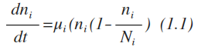 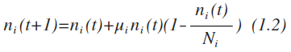

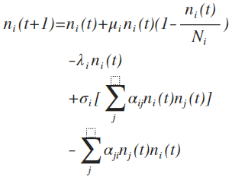

These equations take into consideration the following variables to determine population demography and food web interactions of an individual species: *n* represents current population of species *i*; *µ* represents growth rate per capita; *N* represents maximum population; *λ* represents death rate of the species; σ represents conversion rate of species, which affect the reproduction from predation; α represents predation efficiency.

Using 3 different scripts, we generated two different food webs with identical structures(see below), randomly matched them and simulated the invasion via Python. All invasion simulations ran were successful. This is possibly because both the origin ecosystem and destination ecosystem had identical structures, making them a 100% match.



Our major finding is that for two systems sharing similar or identical structures, when the initial population of the invasive species is very small, the whole system will not undergo large changes, but will self-adjust to a stable state with little disturbance. Additionally, isolated predators that invade with a low initial population are unlikely to experience great population increase. However, when there are too many invaders at the same time, the destination ecosystem is thrown out of order. At the same time, we discovered that if the two systems are similar, the invasion of the species tends to be easier.